Software Requirements Specification
for
Snake Game
Version 1.0
Prepared by :
NISARG RAVI(PES1UG25CS901)
RAMYA HR(PES1UG25CS835)
VINAYAKA (PES1UG25CS855)
PES UNIVERSITY: SOFTWARE ENGINEERING (UE23CS341A)
Created: 27/09/2026

Table of Contents
Revision History
1. Introduction
1.1 Purpose
1.2 Document Conventions
1.3 Intended Audience and Reading Suggestions
1.4 Product Scope
1.5 References
2. Overall Description
2.1 Product Perspective
2.2 Product Functions
2.3 User Classes and Characteristics
2.4 Operating Environment
2.5 Design and Implementation Constraints
2.6 User Documentation
2.7 Assumptions and Dependencies
2.8 Use Case Model
3. External Interface Requirements
3.1 User Interfaces
3.2 Hardware Interfaces
3.3 Software Interfaces
3.4 Communications Interfaces
4. System Features
4.1 Game Initialization
4.2 Movement and Control
4.3 Food, Growth, and Scoring
4.4 Collision and Game-Over Handling
4.5 Session Control
4.6 High Score Persistence
5. Other Nonfunctional Requirements
5.1 Performance Requirements
5.2 Safety Requirements
5.3 Security Requirements
5.3.1 Security Objectives
5.3.2 Security Requirements
5.4 Software Quality Attributes
5.5 Business Rules
6. Other Requirements
Appendix A: Glossary

Revision History
Date | Reason For Changes | Version
27/09/2026 | Initial SRS release, reformatted to the department SRS template. | 1.0

1. Introduction

1.1 Purpose
This Software Requirements Specification (SRS) describes the requirements for Version 1.0 of the Snake Game, a single-player, graphical arcade application developed for this Software Engineering mini-project. This document covers the complete scope of the system as developed for this project; there are no separate subsystems or partial-system SRS documents associated with it.

1.2 Document Conventions
Throughout this document, the keyword “shall” denotes a mandatory requirement (e.g., “The system shall …”). Functional requirements are uniquely identified using the prefix FR- (e.g., FR-1, FR-2); non-functional requirements are identified using the prefix NFR- (e.g., NFR-1, NFR-2); security objectives use the prefix SO- and security requirements use the prefix SEC-. Each System Feature in Section 4 is assigned a priority of High, Medium, or Low to indicate its relative importance; unless stated otherwise, the functional requirements within a feature share that feature's priority.

1.3 Intended Audience and Reading Suggestions
This document is intended for the member(s) of the project team, the course instructor/evaluator, and any other reviewer of the project. Readers seeking a general understanding of the system should read Sections 1 and 2. The appendix is provided for reference and may be consulted as needed.

1.4 Product Scope
The Snake Game is a single-player arcade application in which the player controls a snake that moves continuously around a bounded grid, consuming food items to grow in length while avoiding collisions with the boundary walls and its own body.
The system shall be implemented in C/C++ using SFML (Simple and Fast Multimedia Library), with a graphical window-based interface built on SFML's windowing and event-handling facilities (sf::RenderWindow, sf::Event, sf::Keyboard) for screen drawing and non-blocking keyboard input; SFML's 2-D drawing primitives (sf::RectangleShape, sf::Text) are used to render the grid, snake, food, and HUD.
The system will allow the player to:
- Start, pause, resume, and restart a game session.
- Move the snake using the keyboard and grow it by eating food.
- View the live score and the persisted high score during play and on the Game Over screen.
The following are explicitly out of scope for Version 1.0: networked or local multiplayer functionality, mobile deployment, and any GUI toolkit beyond SFML.

1.5 References
- IEEE Std. 830-1998, IEEE Recommended Practice for Software Requirements Specifications, Institute of Electrical and Electronics Engineers, 1998.
- SFML 2.6 Official API Documentation — Graphics, Window, and System modules (sf::RenderWindow, sf::Event, sf::Keyboard, sf::Clock).
- Software Engineering course material and SRS template (UE23CS341A), Department of CSE, PES University.
- Wiegers, Karl E., Software Requirements Specification template, 1999 (used as the structural template for this document; distributed for use and modification by the author).

2. Overall Description

2.1 Product Perspective
The Snake Game is a new, self-contained, standalone desktop application. It is not a component of a larger system and has no external system dependencies beyond the SFML runtime libraries (Graphics, Window, System) and a standard C++ compiler toolchain. It is developed as an academic project to demonstrate the application of Software Engineering principles including requirements engineering, design, implementation, and testing.

2.2 Product Functions
At a high level, the system provides the following functions:
- Initialize and render the game grid, snake, and food item.
- Accept directional keyboard input and move the snake accordingly.
- Detect food consumption, grow the snake, and update the score.
- Detect collisions with walls or the snake's own body and end the game.
- Allow the player to pause, resume, and restart a game session.
- Persist and display the high score across sessions.

2.3 User Classes and Characteristics
User Class | Characteristics
Player | A single, casual user requiring no specialized technical training. Assumed to have basic familiarity with keyboard-controlled arcade games and standard keys (arrow keys / W-A-S-D). No accessibility accommodations beyond standard keyboard input are assumed for this version.

2.4 Operating Environment
The system is a graphical desktop application. It runs under a native SFML application window on Windows, Linux, or macOS hosts, using the platform's standard graphics/windowing back end (no DOS emulation required). The application window must be sized sufficiently to render a grid of at least 20×20 cells without scrolling or clipping. No network connectivity is required.

2.5 Design and Implementation Constraints
- Implementation language is restricted to C or C++, targeting the C++ compiler/IDE with the SFML library linked (e.g. g++/MinGW, MSVC, or Code::Blocks configured with SFML).
- Rendering is restricted to SFML's Graphics and Window modules (sf::RenderWindow, sf::RectangleShape, sf::Text); no other GUI/multimedia toolkit shall be used.
- The application shall run on a single desktop/laptop machine with no network connectivity requirement.
- Available development and grading time is limited to one academic term (UE23CS341A course schedule).
- The high-score store shall be a local file (plain text or binary) rather than a database or cloud service.

2.6 User Documentation
No formal end-user manual is planned for Version 1.0, given the scope of an academic mini-project. On-screen instructions describing the control scheme shall be displayed for at least 3 seconds at launch in place of a separate manual. Project documentation — including this SRS and the source code — shall be maintained in the project repository for reference by the team and evaluators.

2.7 Assumptions and Dependencies
- The target machine has a keyboard as the primary input device.
- A C++ compiler and the SFML library (v2.6 or later) are installed on the development machine, on Windows, Linux, or macOS.
- The application window is sized sufficiently to render a grid of at least 20×20 cells without scrolling or clipping.

2.8 Use Case Model
This section presents the use case model for the Snake Game, illustrating how the Player actor interacts with the functionality defined in this SRS. Figure 1 shows the overall use case diagram covering the functions described in Sections 2.2 and 4. No actors or functionality beyond those already specified elsewhere in this document are introduced.
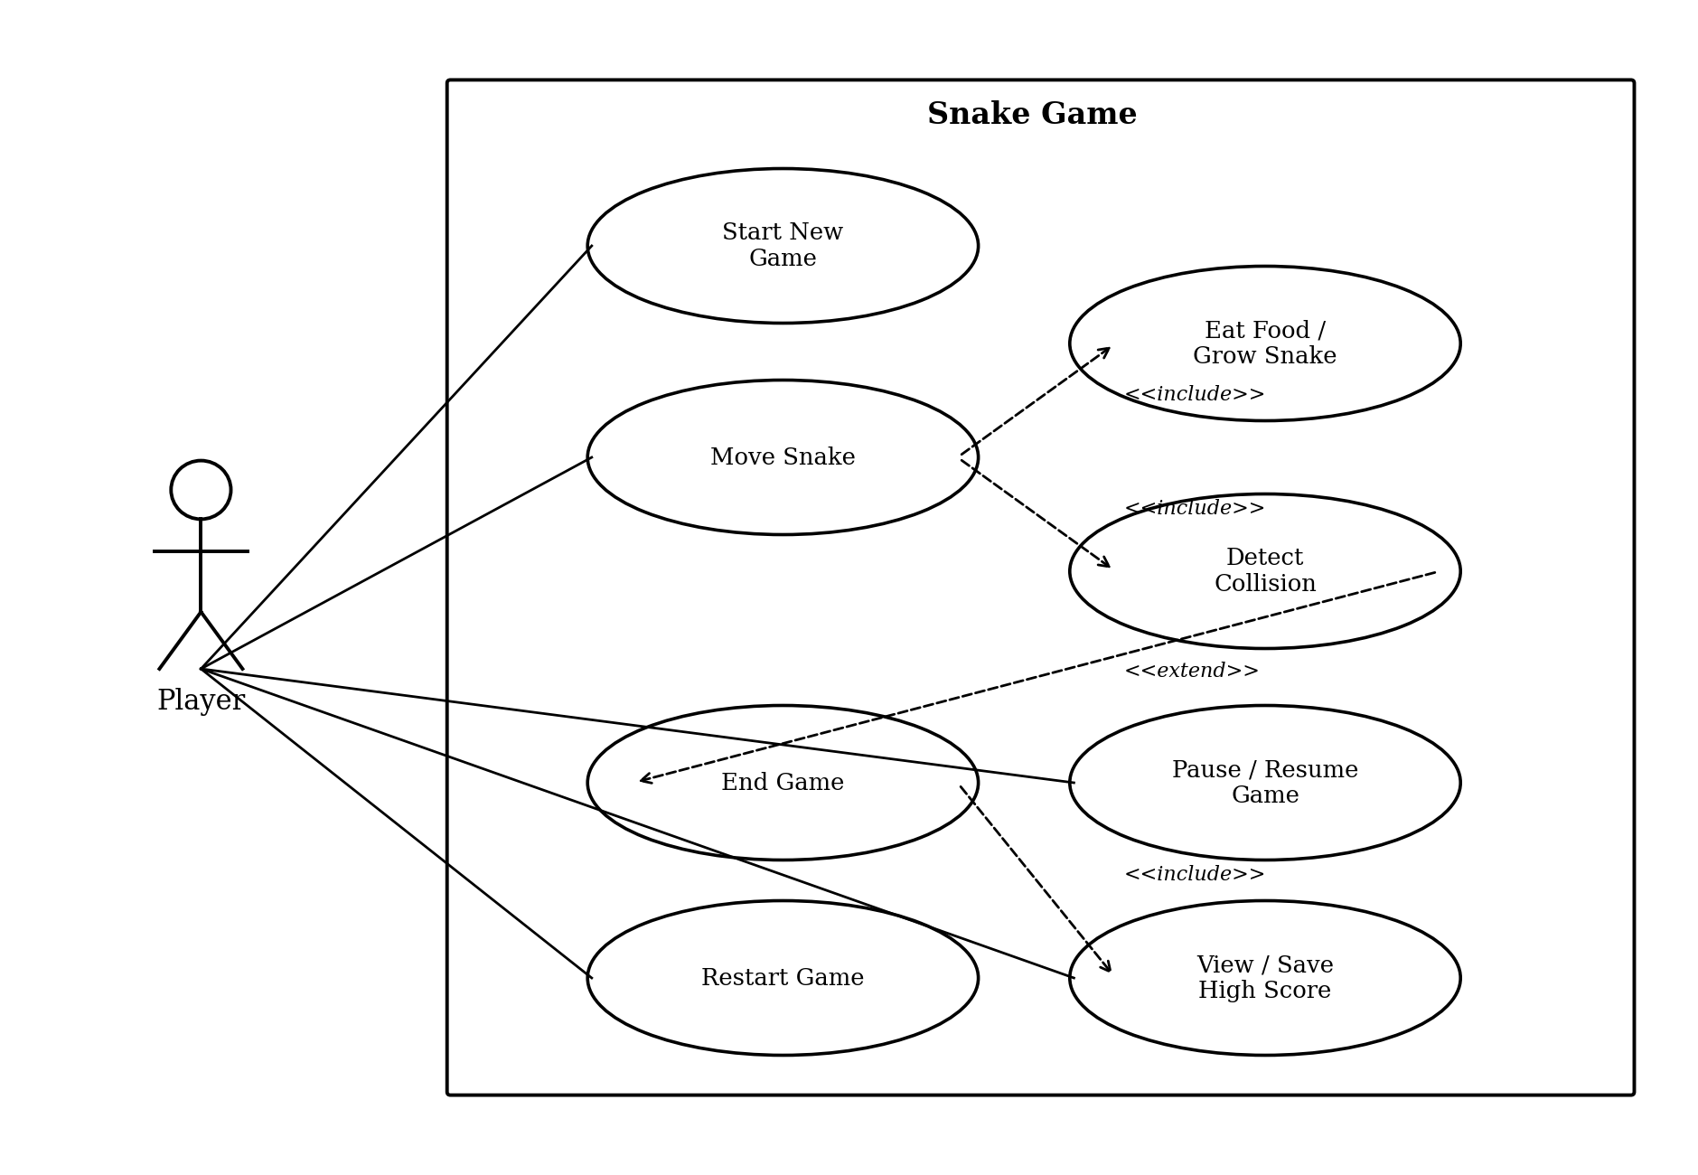
Figure 1: Snake Game Use Case Diagram
As shown in Figure 1, the Player starts a new game, moves the snake, pauses/resumes play, and restarts a session. “Move Snake” includes both food-consumption and collision-detection checks on every tick; a detected collision extends into the “End Game” use case, which in turn includes updating and persisting the high score (FR-13–FR-15).

3. External Interface Requirements

3.1 User Interfaces
The system shall provide an SFML graphics window (default 640×480 px) redrawn each tick, with the game grid, snake, food, score, and high score rendered via SFML shapes and text as a heads-up display (HUD); keyboard-only control, no mouse support.

3.2 Hardware Interfaces
The system requires a standard PC keyboard for input and a standard display device (monitor) for output. No other hardware peripherals are required.

3.3 Software Interfaces
The system shall interface with SFML's Window and Graphics modules (sf::RenderWindow, sf::Event, sf::Keyboard) for windowing, input, and rendering. The high score shall be persisted via the standard C++ file I/O library (std::ifstream/std::ofstream). The application runs natively on the host operating system, with no emulator required.

3.4 Communications Interfaces
None. The system does not communicate over any network.

4. System Features

4.1 Game Initialization ( Priority: High )

4.1.1 Description and Priority
Sets up the grid, the snake, and the first food item at the start of each game session.

4.1.2 Stimulus/Response Sequences
• Player launches the application → System initializes a rectangular game grid, places the snake at the centre with an initial length of 3 segments and a default heading of “right”, and spawns one food item.
• A food item is eaten → System spawns a new food item at a random unoccupied grid cell.

4.1.3 Functional Requirements
ID | Requirement
FR-1 | The system shall initialize a rectangular game grid of configurable size, with a default of 20 columns × 20 rows, upon application launch.
FR-2 | The system shall place the snake at the centre of the grid with an initial length of 3 segments and a default heading of “right” at game start.
FR-3 | The system shall place exactly one food item at a random unoccupied grid cell within 100 ms of game start and after each food item is consumed.

4.2 Movement and Control ( Priority: High )

4.2.1 Description and Priority
Reads keyboard input and advances the snake around the grid on every game tick.

4.2.2 Stimulus/Response Sequences
• Player presses an arrow key or a W/A/S/D key → System changes the snake's heading, unless the new heading would reverse the snake directly onto itself, in which case the input is ignored.
• A game tick elapses → System advances the snake by exactly one grid cell in its current heading.

4.2.3 Functional Requirements
ID | Requirement
FR-4 | The system shall read directional keyboard input (Up, Down, Left, Right or W/A/S/D) and change the snake's heading accordingly, rejecting any input that would reverse the snake directly onto itself.
FR-5 | The system shall advance the snake by exactly one grid cell in the current heading direction on every game tick, with the default tick interval set to 150 ms and adjustable in code between 80 ms and 300 ms.

4.3 Food, Growth, and Scoring ( Priority: High )

4.3.1 Description and Priority
Detects food consumption, grows the snake, and keeps the score display up to date.

4.3.2 Stimulus/Response Sequences
• Snake's head occupies the same cell as the food item → System grows the snake by one segment and increases the score by 10 points within the same tick.
• The score changes → System updates the on-screen score display within the same tick.

4.3.3 Functional Requirements
ID | Requirement
FR-6 | The system shall detect when the snake's head occupies the same cell as the food item within the same tick in which it occurs, and shall increase the snake's length by 1 segment and the player's score by 10 points upon detection.
FR-7 | The system shall display the current score in the game window, updated within the same tick the score changes.

4.4 Collision and Game-Over Handling ( Priority: High )

4.4.1 Description and Priority
Detects collisions with the grid boundary or the snake's own body and ends the current session.

4.4.2 Stimulus/Response Sequences
• Snake's head coordinates fall outside the grid boundary → System detects a collision.
• Snake's head coordinates match any other segment of its own body → System detects a collision.
• A collision is detected → System stops snake movement within one tick and displays a “Game Over” screen showing the final score.

4.4.3 Functional Requirements
ID | Requirement
FR-8 | The system shall detect a collision when the snake's head coordinates match either (a) a coordinate outside the grid boundary, or (b) the coordinates of any other segment of the snake's own body.
FR-9 | Upon detecting a collision, the system shall stop snake movement within one tick and display a “Game Over” screen showing the final score.

4.5 Session Control ( Priority: Medium )

4.5.1 Description and Priority
Lets the player pause, resume, restart, and exit the game.

4.5.2 Stimulus/Response Sequences
• Player presses the pause key (e.g. “P”) during play → System suspends the game tick and all input processing except the pause toggle itself.
• Player presses the pause key again → System resumes the game tick.
• Player presses the restart key (e.g. “R”) on the Game Over screen → System resets the grid, snake, food, and score to their initial states and starts a new session.
• Player presses the exit key (e.g. “Esc” or “Q”) → System exits the application.

4.5.3 Functional Requirements
ID | Requirement
FR-10 | The system shall allow the player to pause and resume the game via a designated key (e.g. “P”), suspending and resuming the game tick and all input processing except the pause toggle itself.
FR-11 | The system shall allow the player to restart a new game session from the Game Over screen via a designated key (e.g. “R”), resetting the grid, snake, food, and score to their initial states as per FR-1 to FR-3.
FR-12 | The system shall allow the player to exit the application from the Game Over screen or the main menu via a designated key (e.g. “Esc” or “Q”).

4.6 High Score Persistence ( Priority: Medium )

4.6.1 Description and Priority
Reads, updates, and displays the high score across play sessions.

4.6.2 Stimulus/Response Sequences
• Application starts → System reads the stored high score from a local file; if the file does not exist, the high score is treated as 0.
• A session ends with a final score greater than the stored high score → System overwrites the stored value before returning to the main menu.
• Player views the HUD or the Game Over screen → System displays the current high score alongside the live score.

4.6.3 Functional Requirements
ID | Requirement
FR-13 | The system shall read the stored high score from a local file at application start; if the file does not exist, the system shall treat the high score as 0.
FR-14 | The system shall compare the final score of each session against the stored high score and, if the final score is greater, shall overwrite the stored value in the local file before returning to the main menu.
FR-15 | The system shall display the current high score alongside the live score during gameplay and on the Game Over screen.

5. Other Nonfunctional Requirements

5.1 Performance Requirements
ID | Requirement
NFR-1 | The system shall complete a full frame redraw in no more than 33 ms per tick when run under SFML on any modern host machine (Windows, Linux, or macOS) with standard desktop hardware.
NFR-2 | The system shall process one full tick (input read, movement, collision check, render) in no more than 50 ms, exclusive of the configured tick delay.

5.2 Safety Requirements
The Snake Game does not control any physical equipment or safety-critical process. No safety requirements beyond the data-protection considerations described in Section 5.3 apply to this system.

5.3 Security Requirements

5.3.1 Security Objectives
The following security objectives apply to all data and functionality described in this SRS, in particular the persisted high-score data and the keyboard input path referenced throughout Sections 4 and 5.5:
ID | Requirement
SO-1 | Data Integrity of Persisted State: ensure that the high-score file cannot be corrupted or left in an inconsistent state by an abnormal program exit, so that subsequent sessions always read a valid, meaningful value.
SO-2 | Input Robustness: ensure that no sequence of keyboard input, however rapid or malformed, can cause undefined behaviour, memory corruption, or a crash in the game engine.
SO-3 | Local Data Tamper-Resilience: ensure that a manually edited or malformed high-score file is detected and handled gracefully rather than trusted blindly, reducing the impact of local tampering.

5.3.2 Security Requirements
The following security requirements implement the objectives in Section 5.3.1 and are consistent with FR-13 and FR-14 (Section 4.6):
ID | Requirement
SEC-1 | The system shall write the high score to a temporary file and atomically rename it over the existing high-score file (rather than truncating and rewriting in place), so that a crash or power loss during a write cannot leave a partially written, corrupted file.
SEC-2 | The system shall validate that the value read from the high-score file is a non-negative integer within a sane upper bound (e.g. ≤ 999,999); if validation fails, the system shall discard the value, log a warning, and reset the high score to 0 rather than using the unvalidated value.
SEC-3 | The system shall use fixed-size, explicitly length-checked character arrays for all input handling (consistent with the standard C++ library available under a modern SFML toolchain), preferring std::string/std::vector/std::array over raw C arrays where practical, and shall never use unbounded C string functions (e.g. gets(), strcpy() without an explicit length bound) anywhere in the codebase.
SEC-4 | The system shall bound-check every array/grid index derived from snake or food coordinates before dereferencing it, rejecting or clamping any index that falls outside the allocated grid array to prevent out-of-bounds reads or writes.

5.4 Software Quality Attributes
ID | Attribute | Requirement
NFR-3 | Reliability | The system shall not crash or terminate abnormally as a result of any single invalid keyboard input; invalid inputs shall be silently ignored.
NFR-4 | Reliability | The system shall correctly persist the high score across at least 100 consecutive play sessions without data corruption, verified by automated regression testing.
NFR-5 | Usability | A first-time player shall be able to start a game and understand the control scheme without external documentation, using on-screen instructions displayed for at least 3 seconds at launch.
NFR-6 | Portability | The compiled SFML-based executable shall run correctly, with no source changes beyond recompilation, on any of the three major desktop operating systems — Windows, Linux, and macOS — given a compatible C++ compiler and the SFML runtime libraries.
NFR-7 | Maintainability | The codebase shall separate game logic, rendering, and input handling into distinct modules/classes (e.g. GameEngine, Renderer, InputHandler) to permit independent modification of each concern.

5.5 Business Rules
- Only one food item exists on the grid at any time; a new item spawns at a random unoccupied cell immediately after the previous one is eaten.
- The stored high score is overwritten only when the current session's final score exceeds the previously stored value; it is never decreased.
- Pausing the game suspends the game tick and all input processing except the pause toggle itself.
- A game session ends immediately upon collision; no further movement or scoring occurs after a collision is detected.
- Restarting a session resets the grid, snake, food, and score to their initial values as defined in Section 4.1; the stored high score is not reset by a restart.

6. Other Requirements
- Build/runtime requirement: the application shall compile and run under C++ (C++17 or later) with the SFML library, on Windows, Linux, or macOS, without source changes.
- Version control requirement: all source code and project documentation shall be developed under version control (e.g. Git), as required by the course.
- No internationalization, localization, accessibility, or external regulatory compliance requirements apply to this academic project.

Appendix A: Glossary
Term | Description
SRS | Software Requirements Specification
FR | Functional Requirement
NFR | Non-Functional Requirement
SO | Security Objective
SEC | Security Requirement
Tick | One discrete update cycle of the game loop (movement + collision check)
SFML | SFML (Simple and Fast Multimedia Library), the multimedia/graphics library (v2.6+) used with a standard C++ compiler for this project
sf::Keyboard | SFML's keyboard-input class, providing real-time, non-blocking key-state queries (sf::Keyboard::isKeyPressed()) used for snake direction control
sf::RenderWindow | SFML's window class, used to create and manage the graphics window into which the grid, snake, food, and HUD are drawn
sf::Clock | SFML's clock class, used to measure elapsed time between frames and drive the fixed-interval game tick
Game Grid | The 2-D array of cells representing the playable board
Collision | An event where the snake's head occupies the same cell as a wall or its own body
High Score | The maximum score achieved across all play sessions, persisted to disk

